Cyber Youth Singapore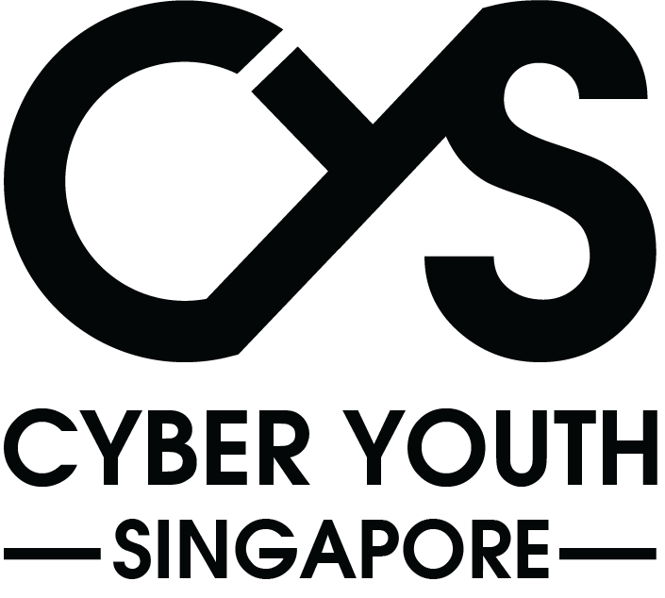

Legislative History

horizontal line

Zheng Yang Davis

# Setup:

## Login Data:

* 1. Na

## Static Files:

* 1. Na

## How to set up:

* 1. Teach day 1 lecture

# Description:

* **Description:**
  + Throughout YCEP, the computer misuse act is a important piece of legislation that we put special emphasis on. However it was’t always called the computer misuse act, what was its old name?
  + Encapsulate the answer in YCEP{}
* **Hint:**
  + 1998 Revised Edition—Computer Misuse Act

# Solution

1. https://sso.agc.gov.sg/Act/CMA1993